BIJU PATNAIK UNIVERSITY OF TECHNOLOGY
ROURKELA, ODISHA-769004


A Major-Project Report On
“E-Vote: ECB”
A Major-Project report submitted in partial fulfillment of the requirements for
the 8th Semester degree of Bachelor of Technology in Computer Science and Engineering
of Biju Patnaik University of Technology, Rourkela

Submitted by

Sl. No. | Name | Registration No.
1 | Surya Subhrajit | 2201329068
2 | Roshan Sahu | 2201329054
3 | Akankshya Kanungo | 2201329003
4 | Tapaswini Dalei | 2201329074

Under the Guidance of
Mr. SANGRAM KESARI TRIPATHY

Head of the department



Department of Computer Science and Engineering
KMBB College of Engineering and Technology
Daleiput, Khurda, Odisha-752056

( 2025-2026 )



CERTIFICATE

Certified that the Major project on the topic “E-Vote: ECB” has been successfully submitted at KMBB College of Engineering and Technology by Surya Subhrajit (Regd. No.: 2201329068), Roshan Sahu (Regd. No.: 2201329054), Akankshya Kanungo (Regd. No.: 2201329003), and Tapaswini Dalei (Regd. No.: 2201329074), in partial fulfillment of the requirements for the 8th Semester Degree of Bachelor of Technology in Computer Science and Engineering of Biju Patnaik University of Technology, Rourkela, during the academic year 2025–2026.

It is certified that all corrections/suggestions indicated for Internal Assessment have been incorporated in the report deposited in the Department Library. The Internship-cum-Project report has been approved as it satisfies the academic requirements in respect of Major Project work for the said degree.

DECLARATION

I, Surya Subhrajit (Regd. No.: 2201329068), a student of 8th Semester B.Tech. in Computer Science and Engineering at KMBB College of Engineering and Technology, hereby declare that the Major Project entitled “E-Vote: ECB” has been carried out by me and submitted in partial fulfillment of the requirements for the 8th Semester Degree of Bachelor of Technology in Computer Science and Engineering of Biju Patnaik University of Technology, Rourkela, during the academic year 2025–2026.

Date: 11 May, 2026  Place: Khordha | Surya Subhrajit  Regd.No: 2201329068

DECLARATION

I, Roshan Sahu (Regd. No.: 2201329054), a student of 8th Semester B.Tech. in Computer Science and Engineering at KMBB College of Engineering and Technology, hereby declare that the Major Project entitled “E-Vote: ECB” has been carried out by me and submitted in partial fulfillment of the requirements for the 8th Semester Degree of Bachelor of Technology in Computer Science and Engineering of Biju Patnaik University of Technology, Rourkela, during the academic year 2025–2026.

Date: 11 May, 2026  Place: Khordha | Roshan Sahu  Regd.No: 2201329054

DECLARATION

I, Akankshya Kanungo (Regd. No.: 2201329003), a student of 8th Semester B.Tech. in Computer Science and Engineering at KMBB College of Engineering and Technology, hereby declare that the Major Project entitled “E-Vote: ECB” has been carried out by me and submitted in partial fulfillment of the requirements for the 8th Semester Degree of Bachelor of Technology in Computer Science and Engineering of Biju Patnaik University of Technology, Rourkela, during the academic year 2025–2026.

Date: 11 May, 2026  Place: Khordha | Akankshya Kanungo  Regd.No: 2201329003

DECLARATION

I, Tapaswini Dalei (Regd. No.: 2201329074), a student of 8th Semester B.Tech. in Computer Science and Engineering at KMBB College of Engineering and Technology, hereby declare that the Major Project entitled “E-Vote: ECB” has been carried out by me and submitted in partial fulfillment of the requirements for the 8th Semester Degree of Bachelor of Technology in Computer Science and Engineering of Biju Patnaik University of Technology, Rourkela, during the academic year 2025–2026.

Date: 11 May, 2026  Place: Khordha | Tapaswini Dalei  Regd.No: 2201329074

ACKNOWLEDGEMENT
The satisfaction and euphoria that accompany the successful completion of any task would be incomplete without the mention of the people who made it possible, whose constant guidance and encouragement crowned the efforts with success.
We would like to profoundly thank Management of KMBB College of Engineering and Technology for providing such a healthy environment for the successful completion of Internship-cum-Project work.
We would like to express my thanks to the Principal Prof. (Dr.) Amar Nath Nayak for his encouragement that motivates me for the successful completion of Internship-Cum-Project work.
It gives me immense pleasure to thank Mr. Sangram Kesari Tripathy, HOD for his constant support and encouragement.
Also, we would like to express my deepest sense of gratitude to my Seminar guide Mr. Sangram Kesari Tripathy Head of Department of Computer Science & Engineering for his constant support and guidance throughout the Internship-Cum-Project work.
We would also like to thank all other teaching and non-teaching staff of Computer Science & Engineering Department who has directly or indirectly helped me in the completion of the Internship-Cum-Project work.
Last, but not the least, we would hereby acknowledge and thank my parents who have been a source of inspiration and also instrumental in the successful completion of the Internship-Cum-Project work.

- Surya Subhrajit
- Akankshya Kanungo
- Roshan Sahu
- Tapaswini Dalei

Abstract

E-Vote: ECB is a full-stack electronic voting simulation system developed as a university project to demonstrate secure and transparent digital democracy. Built with Next.js 14, React 18, TypeScript, and Supabase (PostgreSQL), the application simulates the Election Commission of Bharat by replicating core aspects of the Indian electoral process — including regionalized candidate distribution across Lok Sabha (MP) and State Assembly (MLA) constituencies and a high-fidelity Electronic Voting Machine (EVM) interface.

Voter authentication follows a two-factor process combining Google OAuth 2.0 with simulated Aadhaar number and Voter ID (EPIC) verification via OTP, ensuring only eligible citizens can cast votes. Data integrity is enforced at the database level through PostgreSQL Row Level Security (RLS) policies, which prevent duplicate voting, restrict ballot visibility to constituency-specific candidates, and permanently link a voter's identity to their registered account.

The frontend delivers a responsive interface using Tailwind CSS, Shadcn/UI, Radix UI, and Framer Motion, featuring a public candidate directory with financial disclosures and criminal records, an admin dashboard with Recharts-powered analytics, dark/light mode support, and dynamic avatars via the DiceBear API. The application is deployed on Vercel and serves as a functional prototype for secure civic technology with potential for future enhancements such as real-time vote streaming and biometric integration.

Table of Content

CHAPTER 1
1.1 Introduction
1.2 Problem Statement
1.3 Objective

CHAPTER 2
2.1 Project Scope
2.2 Feasibility Study
2.3 System Architecture

CHAPTER 3
3.1 Tools & Platform Used
3.2 Frontend Used
3.3 Backend Used
3.4 Database Used
3.5 IDE Used

CHAPTER 4
4.1 Frontend Code
4.2 Backend Code

CHAPTER 5
5.1 Future Scope & Limitation

CHAPTER 6
6.1 Conclusion

CHAPTER 7
7.1 Reference

CHAPTER 1
  - Introduction
Introduction – E-Vote: ECB – Secure Digital Election & Voter Verification System

The rapid advancement of web technologies and cloud-based platforms has significantly transformed how civic processes are managed and delivered in the digital age. Electronic governance has evolved from basic information portals into sophisticated systems capable of handling sensitive operations such as identity verification, secure data management, and real-time transaction processing. Today, digital platforms play a crucial role in domains such as public administration, civic engagement, electoral management, and government services.
The objective of this project is to develop E-Vote: ECB, a full-stack web-based electronic voting simulation system that enables verified citizens to participate in a secure and transparent digital election process. The system is built using a modern and scalable architecture, with Supabase (PostgreSQL) forming the backend database and authentication layer, and Next.js 14 with React 18 and TypeScript forming the frontend. This combination ensures high performance, maintainability, and a smooth development workflow aligned with modern full-stack practices.
E-Vote: ECB simulates the functioning of the Election Commission of Bharat (ECB) by replicating core aspects of the Indian electoral process. The system supports regionalized candidate distribution across Lok Sabha (MP) and State Assembly (MLA) constituencies, ensuring that each voter is presented only with candidates relevant to their legally assigned region. A high-fidelity Electronic Voting Machine (EVM) interface further enhances the authenticity of the simulation.
The backend is responsible for managing all data operations through Supabase's PostgreSQL database, enforcing strict Row Level Security (RLS) policies that prevent duplicate voting, restrict ballot visibility to constituency-specific candidates, and permanently link a voter's verified identity to their registered account. Authentication is handled through Google OAuth 2.0 via Supabase Auth, combined with a simulated Aadhaar number and Voter ID (EPIC) verification step followed by OTP confirmation, ensuring that only eligible and verified citizens can cast their votes.
On the frontend, the application is developed using Next.js 14 (App Router) with React 18 and TypeScript, delivering a clean, responsive, and accessible user interface. The UI is designed using Tailwind CSS, Shadcn/UI components, Radix UI primitives, and Framer Motion for animations, ensuring a modern and consistent design across all devices. State and theme management are handled using next-themes for dark/light mode support, while Recharts powers the analytics dashboard with real-time voting statistics.
E-Vote: ECB also provides a rich user experience through features such as a public candidate directory displaying educational background, financial disclosures (Form 26), criminal records, and party manifestos, an admin dashboard for managing the candidate registry and electoral roll, dynamic candidate avatars generated via the DiceBear API, and toast-based notifications using Sonner. The application is deployed on Vercel, leveraging its seamless integration with the Next.js ecosystem.
The system is designed with security, modularity, and scalability in mind, making it suitable for future enhancements such as real-time vote streaming, biometric integration, multi-election support, and advanced analytics.

The application primarily supports two roles:
- Voters – who can register via Google OAuth, complete Aadhaar-based identity verification, view constituency-specific candidates, and cast their votes securely through the EVM interface.
- Administrators – who can manage the candidate registry, monitor the electoral roll, view voting analytics, and oversee the overall election process through a protected dashboard.

With the increasing demand for transparent and tamper-proof digital governance tools, E-Vote: ECB serves as both a practical implementation of full-stack web development and a real-world demonstration of applying modern technology to civic systems. It highlights key concepts such as database-level security with RLS, OAuth-based authentication, regionalized data filtering, and responsive frontend development, while ensuring high performance, data integrity, and an enhanced user experience.

1.2 Problem Statement

Traditional electoral processes are heavily paper-based, time-consuming, and prone to human error, fraud, and logistical inefficiencies. While Electronic Voting Machines (EVMs) exist in physical form, there is no widely accessible digital simulation that demonstrates how a secure, regionalized, and identity-verified online voting system could function in the Indian electoral context.

Key challenges this project addresses:

Identity Fraud – Without proper verification, digital voting systems are vulnerable to impersonation. There is a need to link a voter's digital account to their official identity (Aadhaar + Voter ID) before allowing participation.

Duplicate Voting – Ensuring one citizen casts exactly one vote per election type (MP and MLA) is a critical integrity requirement that is difficult to enforce without database-level constraints.

Regionalized Ballot Distribution – India's electoral system is constituency-based. A voter in West Bengal should only see West Bengal candidates. Generic systems fail to implement this geographic filtering correctly.

Lack of Transparency in Candidate Information – Voters often lack easy access to candidate backgrounds, financial disclosures, and criminal records. A centralized, publicly accessible candidate directory is missing from most simulations.

Insecure Authentication – Simple username/password systems are insufficient for a civic platform. A stronger, multi-step verification process is needed.

To address these, E-Vote: ECB proposes a full-stack simulation using Next.js 14, Supabase (PostgreSQL with RLS), and Google OAuth combined with Aadhaar-based OTP verification — enforcing electoral integrity at both the application and database levels.

1.3 Objectives

The primary objective of this project is to design and develop E-Vote: ECB, a web-based electronic voting simulation that demonstrates how a secure, transparent, and regionalized digital election system can be built using modern full-stack technologies.

Functional Objectives:

Voter Authentication & Verification

Implement Google OAuth 2.0 for account creation and login.

Enforce a two-step identity verification process using Aadhaar number and Voter ID (EPIC) with simulated OTP confirmation.

Permanently link a verified voter identity to their account to prevent switching or re-verification.

Regionalized Voting

Filter candidates based on the voter's verified state and constituency (MP and MLA).

Ensure each voter sees only the ballot relevant to their legal electoral jurisdiction.

Vote Integrity

Enforce one-vote-per-citizen per election type using PostgreSQL RLS policies and database constraints.

Prevent any modification or deletion of cast votes.

Candidate Directory

Provide a public-facing directory of all candidates with detailed profiles including education, financial assets and liabilities (Form 26), criminal records, party affiliation, and manifesto.

Admin Dashboard

Allow administrators to manage candidates (create, edit, delete) and view the electoral roll.

Display voting analytics including turnout statistics and candidate standings using charts.

UI/UX

Deliver a responsive, accessible interface with dark/light mode support.

Simulate an EVM-style voting terminal for an authentic experience.

Non-Functional Objectives:

Ensure data security through RLS policies and OAuth-based authentication.

Build a modular codebase deployable on Vercel with minimal configuration.

Design the system to be extensible for future features such as real-time vote counts, biometric verification, and multi-election support.

1.4 Scope

E-Vote: ECB covers the complete flow of a digital election simulation — from voter registration and identity verification to ballot casting and result analytics. The scope includes:

User-facing features: registration, Aadhaar/EPIC verification, constituency-based voting, and candidate browsing.

Admin features: candidate management, user management, and voting analytics dashboard.

Database design: voters, profiles, candidates, and votes tables with RLS enforcement.

Deployment: production-ready build hosted on Vercel with Supabase as the backend.

The system is scoped as an academic simulation and does not integrate with any real government database, biometric hardware, or official electoral infrastructure. All voter data used is fictional and generated for demonstration purposes.

CHAPTER 2

2.1 Project Scope

The scope of this project is to design and develop E-Vote: ECB, a web-based electronic voting simulation system using Next.js 14 with React 18 and TypeScript for the frontend, and Supabase (PostgreSQL) for the backend database and authentication. The system simulates a secure, regionalized digital election platform inspired by the Indian electoral process.

The application is intended for academic demonstration purposes, targeting users who want to understand how a secure digital voting system can be built using modern full-stack technologies. It focuses on voter identity verification, constituency-based ballot distribution, and tamper-proof vote recording.

In-Scope Features

Voter Authentication & Verification

Google OAuth 2.0 login via Supabase Auth.

Two-step identity verification using Aadhaar number and Voter ID (EPIC) with simulated OTP.

Permanent account-to-voter-identity linking after verification.

Regionalized Voting

Constituency-based candidate filtering for MP (Lok Sabha) and MLA (State Assembly) elections.

Voters see only candidates from their verified state and constituency.

EVM Interface

A high-fidelity digital terminal simulating the look and feel of a physical Electronic Voting Machine.

Candidate Directory

Public-facing directory with candidate profiles including education, financial disclosures (Form 26), criminal records, party affiliation, and manifesto.

Admin Dashboard

Candidate registry management (create, edit, delete).

Electoral roll management and voting analytics with charts.

Vote Integrity

One-vote-per-citizen enforcement via PostgreSQL Row Level Security (RLS) policies.

Database-level constraints preventing duplicate or modified votes.

2.1.1 Out of Scope

Integration with real government databases (Aadhaar API, ECI electoral roll).

Biometric hardware authentication.

Real-time vote count streaming (planned as a future enhancement).

Native mobile application development.

Multi-election or multi-constituency admin configuration through the UI.

Offline functionality, as the system requires an active internet connection for Supabase communication.

2.2 Feasibility Study

The feasibility study evaluates the practicality of developing E-Vote: ECB using modern full-stack technologies. It examines technical, economic, operational, and schedule feasibility to confirm the system is implementable within academic constraints.

2.2.1 Technical Feasibility

Technology Stack: Next.js 14 with React 18 and TypeScript provides a robust, scalable frontend. Supabase handles the backend database, authentication, and real-time capabilities without requiring a separate server.

Authentication: Supabase Auth with Google OAuth 2.0 is well-documented and straightforward to integrate, with built-in session management.

Database Security: PostgreSQL RLS policies enforce vote integrity and data access control at the database level, reducing reliance on application-layer security alone.

Deployment: Vercel provides seamless deployment for Next.js applications with zero configuration, and Supabase offers a managed cloud PostgreSQL instance.

✅ Technically feasible using proven, well-supported technologies with strong community documentation.

2.2.2 Economic Feasibility

No hardware investment required; development runs on a standard personal computer.

All core technologies (Next.js, React, TypeScript, Tailwind CSS, Supabase free tier) are open-source or free for academic use.

Vercel's free tier covers deployment needs for a project at this scale.

No labor cost as this is an academic project developed individually.

✅ Economically feasible with near-zero cost for development and deployment.

2.2.3 Operational Feasibility

The interface is clean, responsive, and intuitive — voters can complete the verification and voting process with minimal steps.

The admin dashboard provides straightforward tools for managing candidates and monitoring election data.

The system is fully web-based and works across desktop and mobile browsers without any installation.

✅ Operationally feasible with a user-friendly workflow suitable for demonstration and academic evaluation.

2.2.4 Schedule Feasibility

The project is divided into clear phases: database design, authentication setup, voting logic, UI development, admin dashboard, and testing.

Use of Supabase eliminates the need to build a separate backend server, significantly reducing development time.

Familiarity with Next.js and React accelerates frontend development.

✅ Completable within a standard academic semester with well-defined milestones.

2.3 System Architecture

2.3.1 Overview

E-Vote: ECB follows a client–database architecture powered by Supabase, where the Next.js frontend communicates directly with the Supabase backend via the @supabase/supabase-js client SDK. There is no separate application server — Supabase handles authentication, database queries, and access control.

Core components:

Frontend (Next.js 14 + React 18 + TypeScript) — Renders all pages, handles user interaction, manages auth state, and communicates with Supabase.

Supabase Auth — Manages Google OAuth 2.0 login, session tokens, and user identity.

Supabase Database (PostgreSQL) — Stores all application data across four core tables: profiles, voters, candidates, and votes. RLS policies enforce access control at the row level.

DiceBear API — Generates dynamic candidate avatars based on candidate names.

2.3.2 Component Breakdown

A. Frontend (Next.js 14 + React 18 + TypeScript)

Renders public pages (home, candidates, about) and protected pages (vote, dashboard).

Manages authentication state via useAuthMiddleware hook using Supabase Auth session.

Handles voter verification flow (Aadhaar + EPIC input → OTP → profile update).

Displays constituency-filtered candidate ballots and the EVM voting interface.

Admin dashboard renders candidate management forms and Recharts-based analytics.

UI built with Tailwind CSS, Shadcn/UI, Radix UI primitives, and Framer Motion.

B. Supabase Auth

Handles Google OAuth 2.0 sign-in and callback.

Provides session tokens used to identify the current user across all database operations.

Auth state is listened to in real time via onAuthStateChange.

C. Supabase Database (PostgreSQL + RLS)

profiles — Stores user metadata: is_admin, is_voter_verified, linked_voter_id, state, constituency_mp, constituency_mla.

voters — Stores electoral roll data: voter_id_epic, aadhar_number, phone_number, state, constituency_mp, constituency_mla.

candidates — Stores candidate profiles: name, party_name, type (MP/MLA), state, constituency, education, assets, liabilities, criminal_records, photo_url.

votes — Records cast votes: voter_profile_id, candidate_id, vote_type (MP/MLA). RLS prevents duplicate entries.

D. DiceBear API

Generates SVG avatars dynamically for candidates without a photo, using the candidate's name as a seed.

Data Flow Summary

Login — User signs in via Google OAuth. Supabase Auth creates a session and a corresponding entry in profiles.

Voter Verification — User submits Aadhaar + EPIC. System queries the voters table, validates the match, simulates OTP, and on confirmation updates profiles with verification status and constituency data.

Ballot Loading — Verified voter's state and constituency are read from profiles. The candidates table is queried and filtered to return only relevant MP and MLA candidates.

Vote Casting — User selects a candidate and confirms. A record is inserted into the votes table. RLS policies block any second vote of the same type from the same profile.

Admin Operations — Admin users (identified by is_admin = true) access the dashboard to create/edit candidates and view aggregated vote data via Supabase queries rendered in Recharts charts.

CHAPTER 3

TOOLS & PLATFORMS USED

E-Vote: ECB is built using a modern full-stack web technology stack. The following tools and platforms were used across frontend development, backend services, and third-party integrations.

3.1 Frontend

The frontend handles all user-facing pages including voter verification, ballot casting, candidate directory, and the admin dashboard. It is built for performance, responsiveness, and accessibility.

Next.js 14 (App Router)

Next.js is the core framework used for the frontend. It provides:

File-based routing using the App Router for clean and scalable page structure.

Server-side rendering (SSR) and static generation for improved performance.

Built-in API route support and seamless Vercel deployment.

Next.js serves as the foundation of the entire application, managing routing, layouts, and page rendering.

React 18

React is used to build all interactive UI components. It provides:

Component-based architecture for reusable and maintainable UI elements.

Efficient rendering using a virtual DOM.

Dynamic state-driven updates for the voting interface and dashboard.

TypeScript

TypeScript adds static typing to the JavaScript codebase. It provides:

Early error detection and improved code reliability.

Strongly typed component props, database models, and API responses.

Better maintainability across a growing codebase.

Tailwind CSS & Shadcn/UI

Used for all styling and UI component design. They provide:

Utility-first CSS for rapid and consistent UI development.

Pre-built, accessible components (buttons, dialogs, badges, alerts) via Shadcn/UI.

Responsive design ensuring compatibility across desktop and mobile devices.

Radix UI & Lucide React

Radix UI primitives are used as the base for accessible interactive components such as dropdowns, selects, and navigation menus. Lucide React provides consistent iconography throughout the interface.

Framer Motion

Used in MagicUI components for smooth animations including number tickers, scroll-based effects, and text reveals, enhancing the visual experience of the landing and dashboard pages.

next-themes

Handles dark and light mode toggling with system preference detection, storing the user's theme preference persistently.

3.2 Backend & Database

E-Vote: ECB uses Supabase as its entire backend infrastructure, eliminating the need for a separate application server. Supabase provides authentication, a managed PostgreSQL database, and a JavaScript client SDK.

Supabase

Supabase is the core backend platform of the application. It provides:

A managed PostgreSQL database with a web-based table editor and SQL editor.

A JavaScript client (@supabase/supabase-js) for direct frontend-to-database communication.

Built-in Row Level Security (RLS) for enforcing data access policies at the database level.

Real-time capabilities for potential live data updates.

Supabase Auth (Google OAuth 2.0)

Authentication is handled entirely through Supabase Auth. It provides:

Google OAuth 2.0 sign-in with automatic session management.

Secure JWT-based session tokens used to identify users across all database operations.

Real-time auth state listening via onAuthStateChange for seamless protected route handling.

PostgreSQL (via Supabase)

The relational database stores all application data across four core tables:

profiles — User metadata including admin flag, voter verification status, and constituency info.

voters — Electoral roll with Aadhaar, EPIC number, phone, state, and constituency data.

candidates — Candidate profiles including party, type (MP/MLA), education, assets, liabilities, and criminal records.

votes — Cast vote records with RLS policies preventing duplicate entries.

Row Level Security policies enforce:

One vote per citizen per election type (MP and MLA).

Voters can only read candidates from their own constituency.

Profiles can only be updated by their own owner.

3.3 Third-Party Integrations

DiceBear API

Used to generate dynamic SVG avatars for candidates who do not have a profile photo. Avatars are generated using the candidate's name as a seed, ensuring unique and consistent visuals across the candidate directory.

Recharts

A React-based charting library used in the admin dashboard to visualize voting analytics including turnout statistics and candidate vote standings.

Sonner

A toast notification library used to display real-time feedback messages for actions such as successful votes, verification errors, and form submissions.

Vercel

The application is deployed on Vercel, which provides seamless CI/CD integration with Next.js, automatic preview deployments, and a global CDN for fast page loads.

CHAPTER 4

SOURCE CODE

This chapter includes selected portions of the source code that represent the core functionality of the E-Vote Bharat Election Portal. To ensure security, sensitive details such as API keys, database credentials, and critical backend configurations have been intentionally excluded or replaced with environment variables.

Copyright Warning:

The source code presented here is the intellectual property of the project developer. Unauthorized use, reproduction, or distribution of this code in any form is strictly prohibited and may lead to legal action under applicable copyright laws.

Project Structure Overview
The E-Vote project follows a modern full-stack architecture using Next.js, integrating both frontend and backend logic into a unified framework with Supabase serving as the robust backend-as-a-service.
Below is a structured breakdown of the codebase:
- Backend Structure (Supabase & PostgreSQL)
The backend is powered by Supabase, providing a managed PostgreSQL database, authentication, and real-time capabilities.
- Tables:
- profiles – Stores user-specific data and verification status.
- voters – Contains the official electoral roll (Aadhaar/Voter ID mappings).
- candidates – Stores information about candidates (MP/MLA), their parties, and constituencies.
- votes – Record of cast votes (secured via Row Level Security to ensure anonymity and uniqueness).
- Authentication: Supabase Auth handles secure login, registration, and session management.
- Frontend Structure (Next.js & React)
The frontend is developed using Next.js with TypeScript and Tailwind CSS, following a component-based architecture for high performance and scalability.
- app/ – Contains the routing logic and page layouts using the Next.js App Router.
- components/ – Reusable UI components such as VotePage, Dashboard, CandidateCard, and Navbar.
- lib/ – Utility functions and database configuration (Supabase client initialization).
- public/ – Static assets like logos, party symbols, and icons.
- tailwind.config.ts – Configuration for the design system and theme tokens.

4.2 Core Library & Utilities
- src/lib/supabase.ts
import { createClient } from '@supabase/supabase-js'

const supabaseUrl = process.env.NEXT_PUBLIC_SUPABASE_URL || ''
const supabaseAnonKey = process.env.NEXT_PUBLIC_SUPABASE_ANON_KEY || ''

export const supabase = createClient(supabaseUrl, supabaseAnonKey)

- src/lib/utils.ts
import { type ClassValue, clsx } from "clsx";
import { twMerge } from "tailwind-merge";
import { supabase } from "@/lib/supabase";

export function cn(...inputs: ClassValue[]) {
return twMerge(clsx(inputs));
}

export const validateAadhaar = (aadhaar: string) => {
const regex = /^[2-9]{1}[0-9]{3}\s?[0-9]{4}\s?[0-9]{4}$/;
return regex.test(aadhaar);
};

export const fetchCandidates = async () => {
const { data, error } = await supabase.from('candidates').select('*');
if (error) return [];
return data.map((candidate) => ({
id: candidate.id,
name: candidate.name || "No Name Provided",
description: candidate.description || "No Description Provided",
type: candidate.type,
partyName: candidate.party_name || "Swadhin",
state: candidate.state,
constituency: candidate.constituency,
}));
};
4.3 Application Layout & Infrastructure

- src/app/layout.tsx
import type { Metadata } from "next";
import { Inter } from "next/font/google";
import { Toaster } from "@/components/ui/sonner";
import "./globals.css";
import { ThemeProvider } from "@/components/theme-provider";
import LayoutWrapper from "@/components/LayoutWrapper";

const inter = Inter({ subsets: ["latin"] });

export const metadata: Metadata = {
title: "Bharat Election Portal — Lok Sabha 2029",
description: "Digital Voting Platform for Indian Parliamentary Elections",
};

export default function RootLayout({ children }: { children: React.ReactNode }) {
return (
<html lang="en">
<body className={inter.className}>
<ThemeProvider attribute="class" defaultTheme="system" enableSystem>
<LayoutWrapper>{children}</LayoutWrapper>
</ThemeProvider>
<Toaster position="top-center" />
</body>
</html>
);
}

- src/app/auth/middleware/useAuthMiddleware.tsx
import { useEffect, useState } from "react";
import { useRouter } from "next/navigation";
import { supabase } from "@/lib/supabase";
import { User } from "@supabase/supabase-js";

export const useAuthMiddleware = () => {
const [user, setUser] = useState<User | null>(null);
const [loading, setLoading] = useState(true);
const [isAdmin, setIsAdmin] = useState<boolean | null>(null);
const [isVoterVerified, setIsVoterVerified] = useState<boolean | null>(null);
const router = useRouter();

useEffect(() => {
const getInitialSession = async () => {
const { data: { session } } = await supabase.auth.getSession();
setUser(session?.user ?? null);
setLoading(false);
};
getInitialSession();
const { data: { subscription } } = supabase.auth.onAuthStateChange((_event, session) => {
setUser(session?.user ?? null);
setLoading(false);
});
return () => subscription.unsubscribe();
}, []);

useEffect(() => {
const fetchProfileData = async () => {
if (user && !loading) {
const { data } = await supabase.from('profiles').select('is_admin, is_voter_verified').eq('id', user.id).single();
setIsAdmin(data?.is_admin || false);
setIsVoterVerified(data?.is_voter_verified || false);
}
};
fetchProfileData();
}, [user, loading]);

return { user, loading, isAdmin, isVoterVerified };
};

4.4 Key Components & Pages

- src/components/Navbar.tsx
"use client";
import { useRouter } from "next/navigation";
import { supabase } from "@/lib/supabase";
import { Avatar, AvatarFallback, AvatarImage } from "@/components/ui/avatar";
import { DropdownMenu, DropdownMenuContent, DropdownMenuItem, DropdownMenuTrigger } from "@/components/ui/dropdown-menu";
import { ModeToggle } from "./ThemeToggle";
import Link from "next/link";
import { useAuthMiddleware } from "@/app/auth/middleware/useAuthMiddleware";
import { Button } from "./ui/button";
import { Landmark } from "lucide-react";

export default function Navbar() {
const { user, isVoterVerified } = useAuthMiddleware();
const router = useRouter();

const handleLogout = async () => {
await supabase.auth.signOut();
router.push("/");
};

return (
<header className="sticky top-0 bg-[#1a1a2e] text-white shadow-lg">
<div className="mx-auto px-4 flex justify-between items-center py-3">
<Link href={"/"} className="flex items-center gap-3">
<Landmark className="w-5 h-5" />
<span className="font-black">Bharat Election Project</span>
</Link>
<nav className="flex items-center gap-8">
<Link href="/candidates">Candidates</Link>
<Link href="/vote">Vote</Link>
{user ? (
<DropdownMenu>
<DropdownMenuTrigger><Avatar><AvatarImage src={user.user_metadata?.avatar_url} /></Avatar></DropdownMenuTrigger>
<DropdownMenuContent><DropdownMenuItem onClick={handleLogout} disabled={isVoterVerified}>Sign Out</DropdownMenuItem></DropdownMenuContent>
</DropdownMenu>
) : (
<Link href="/auth/login"><Button>Sign In</Button></Link>
)}
</nav>
</div>
</header>
);
}

- src/components/VotePage.tsx
"use client";
import { useState, useCallback } from "react";
import { Fingerprint, CheckCircle2 } from "lucide-react";
import { supabase } from "@/lib/supabase";

const VerificationGate = ({ onVerified, user }) => {
const [step, setStep] = useState("aadhaar");
const [aadhaar, setAadhaar] = useState("");
const [voterId, setVoterId] = useState("");

const handleSearchVoter = async () => {
const { data } = await supabase.from('voters').select('*').eq('voter_id_epic', voterId.toUpperCase()).single();
if (data) setStep("otp");
};

const handleVerifyOtp = async () => {
await supabase.from('profiles').update({ is_voter_verified: true }).eq('id', user.id);
setStep("verified");
setTimeout(() => onVerified(), 1500);
};

return (
<div className="p-8 bg-white rounded-3xl shadow-2xl">
{step === "aadhaar" && (
<div className="space-y-6">
<input placeholder="Voter ID" value={voterId} onChange={(e) => setVoterId(e.target.value)} />
<Button onClick={handleSearchVoter}>Search Voter Record</Button>
</div>
)}
{step === "otp" && <Button onClick={handleVerifyOtp}>Verify OTP</Button>}
</div>
);
};

export default function VotePage() {
const { user } = useAuthMiddleware();
const [isVerified, setIsVerified] = useState(false);

const loadData = useCallback(async () => {
const { data: profile } = await supabase.from('profiles').select('is_voter_verified').eq('id', user.id).single();
if (profile?.is_voter_verified) setIsVerified(true);
}, [user]);

return isVerified ? <div className="voting-terminal">Verified Terminal</div> : <VerificationGate user={user} onVerified={loadData} />;
}

- src/components/CandidateCard.tsx
"use client";
import { useState } from "react";
import { supabase } from "@/lib/supabase";
import { toast } from "sonner";
import { Vote } from "lucide-react";

const CandidateCard = ({ id, name, type, voted = false }) => {
const [isLoading, setIsLoading] = useState(false);

const handleVote = async () => {
const { data: { user } } = await supabase.auth.getUser();
setIsLoading(true);
const { error } = await supabase.from('votes').insert({ voter_profile_id: user.id, candidate_id: id, vote_type: type });
if (error) toast.error("Failed to cast vote");
else toast.success("Vote Recorded");
setIsLoading(false);
};

return (
<div className="card">
<h3>{name}</h3>
<Button onClick={handleVote} disabled={isLoading || voted}>Vote</Button>
</div>
);
};

- src/components/DashboardPage.tsx
"use client";
import { useEffect, useState } from "react";
import { supabase } from "@/lib/supabase";

export function DashboardPage() {
const [mpVotingData, setMpVotingData] = useState({ voted: 0, notVoted: 0 });

useEffect(() => {
const fetchVotingData = async () => {
const [profilesResponse, votesResponse] = await Promise.all([
supabase.from('profiles').select('id', { count: 'exact' }),
supabase.from('votes').select('vote_type')
]);
const totalProfiles = profilesResponse.count || 0;
const votes = votesResponse.data || [];
const votedMP = votes.filter(v => v.vote_type === 'MP').length;
setMpVotingData({ voted: votedMP, notVoted: totalProfiles - votedMP });
};
fetchVotingData();
}, []);

return (
<div className="dashboard">
<h2>MP Turnout: {mpVotingData.voted} / {mpVotingData.voted + mpVotingData.notVoted}</h2>
</div>
);
}

4.5 Project Screenshots:
Landing Page:
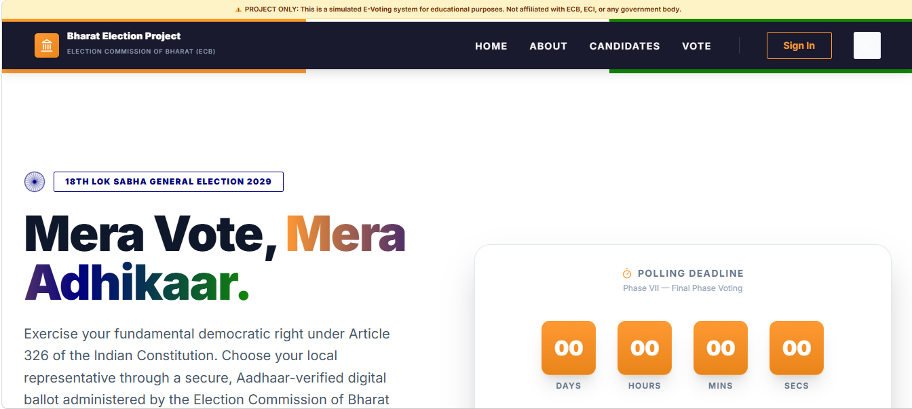

How E-Vote: ECB Works
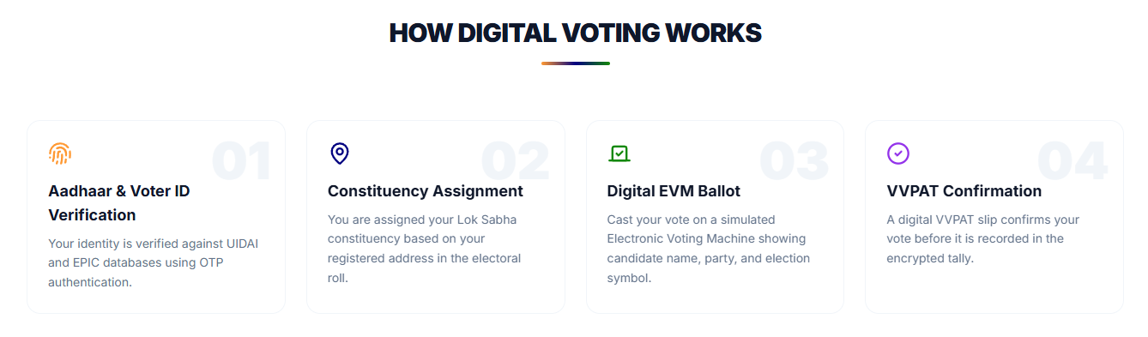
Candidate Page: 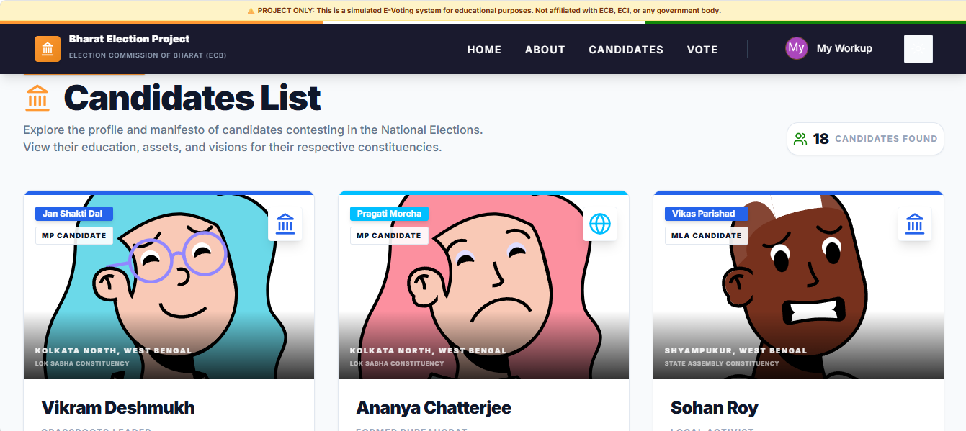

Voting Verification: 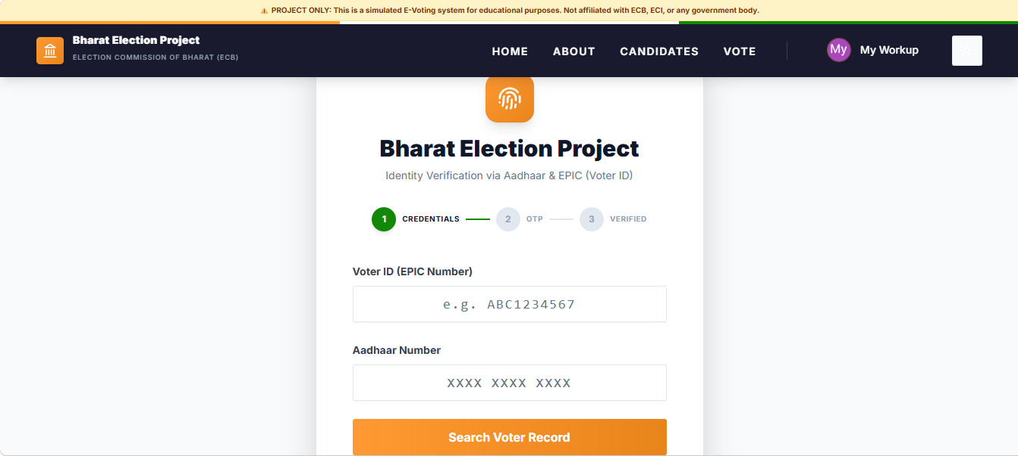

Voting Page (UI): 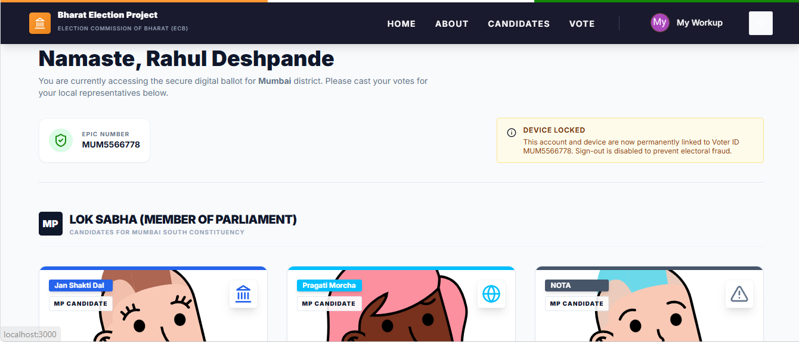

Candidate Profile:
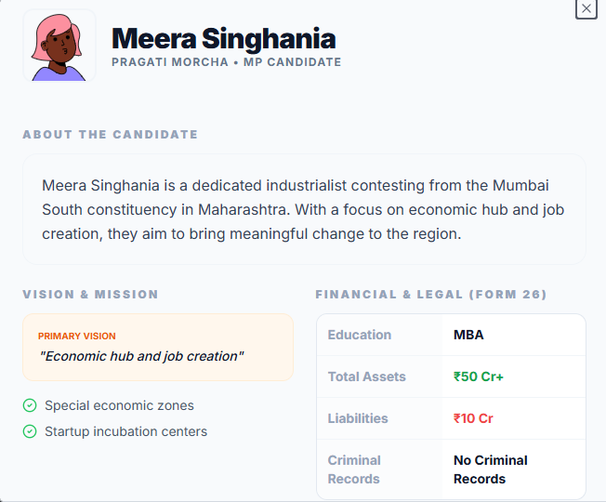

Vote Page (Not Yet Voted):
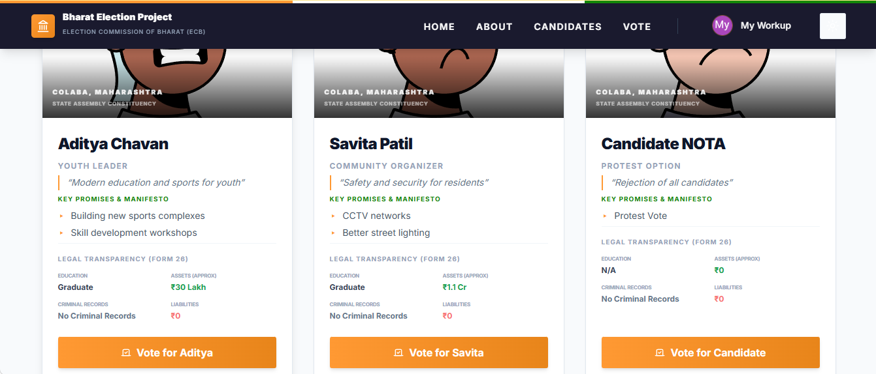

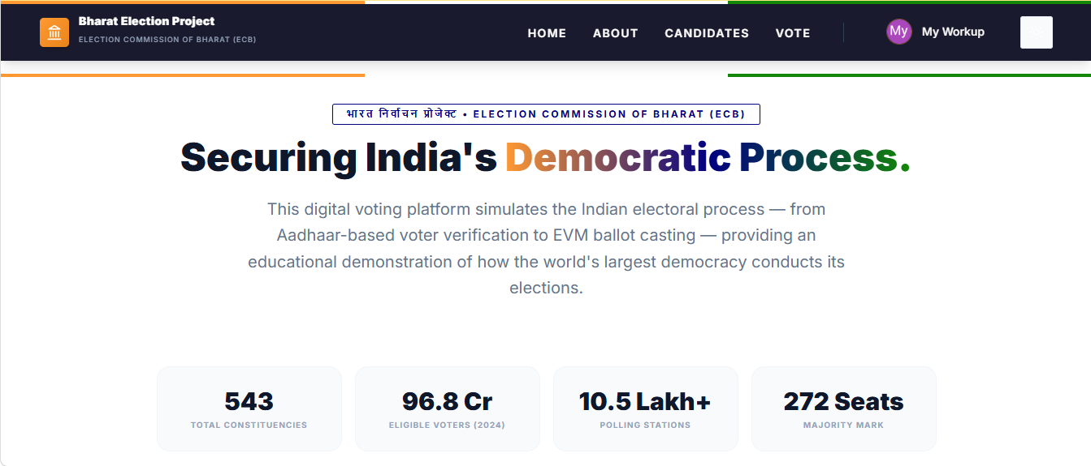

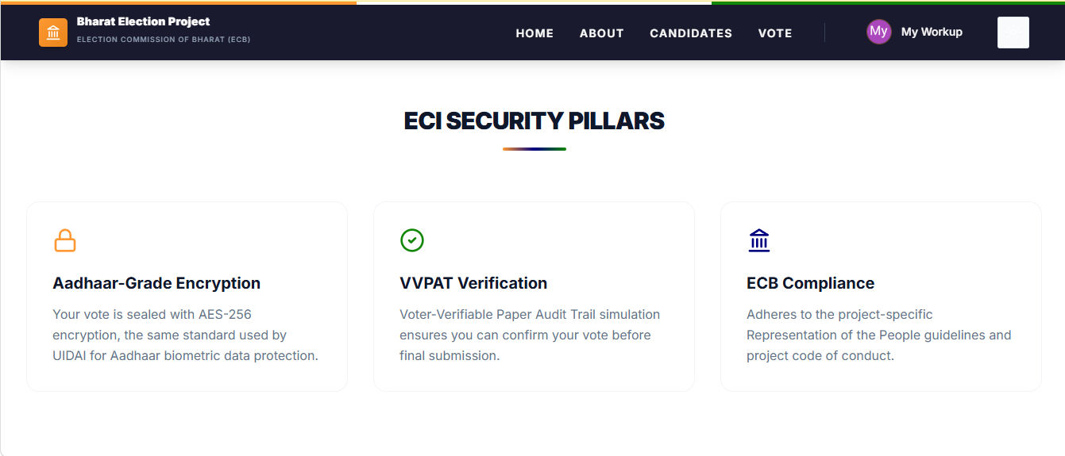

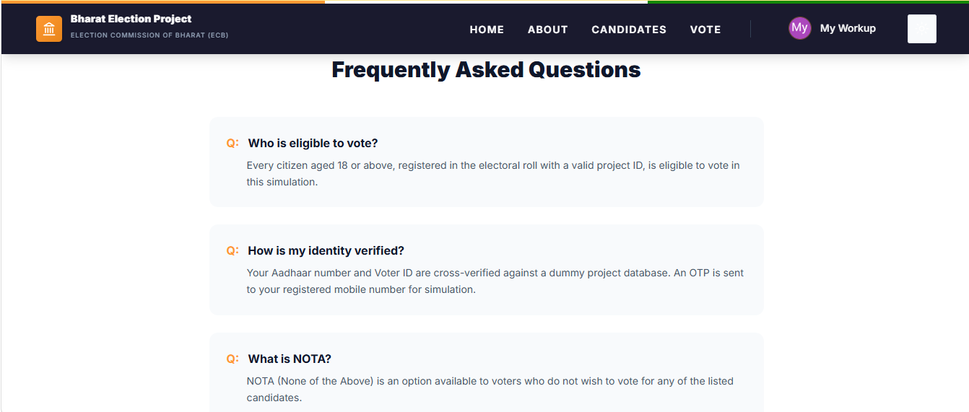

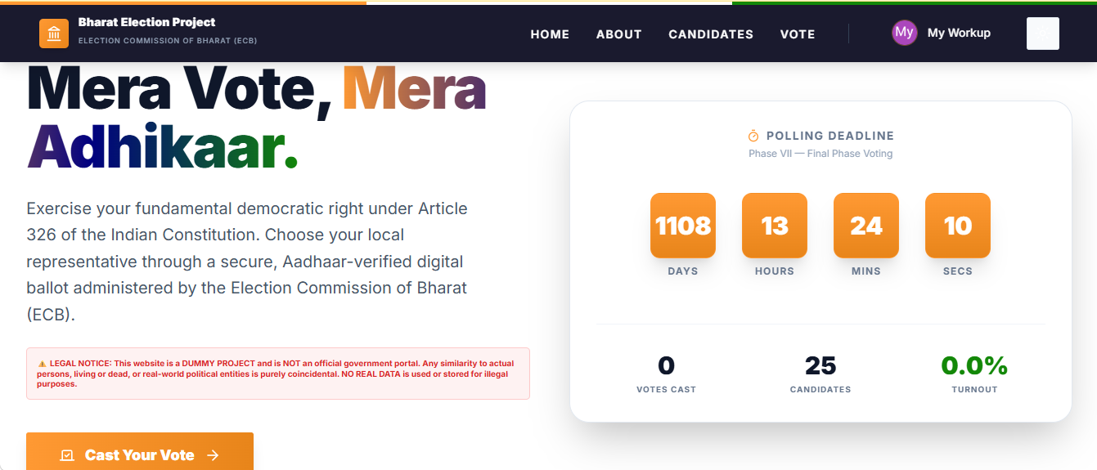

CHAPTER 5
5.1 Future Scope
The E-Vote Bharat Election Portal provides a strong foundation for building a secure and scalable digital voting system. It can be further enhanced with advanced features to improve security, transparency, and accessibility. Potential future improvements include:
- Biometric Authentication Integration: Incorporating Aadhaar-based biometric verification (fingerprint or iris scanning) to ensure the highest level of voter identity assurance.
- Blockchain for Vote Integrity: Implementing a decentralized ledger system to make the voting process completely immutable and transparent, preventing any possibility of data tampering.
- Multi-Language Support: Providing the interface in multiple Indian regional languages to ensure inclusivity for citizens across various states.
- Real-Time Result Analytics: Developing an advanced dashboard for real-time vote counting and demographic turnout analysis using interactive heatmaps.
- Mobile Application Development: Extending the portal to Android and iOS platforms using Flutter or React Native for a more seamless mobile voting experience.
- AI-Powered Voter Assistant: Integrating an AI chatbot to help voters find their constituencies, understand candidate profiles, and navigate the voting process.
- Offline Voting with Sync: Enabling voting in remote areas with limited connectivity through encrypted local storage that synchronizes once a stable connection is established.
- Smart Contract Integration: Using smart contracts to automate the validation of election rules and the final tallying process without manual intervention.
5.2 Limitations
While the current version of the E-Vote Bharat Election Portal provides a functional and secure digital voting experience, it still has certain limitations that can be addressed in future iterations:
- Digital Literacy Requirement: The system assumes a basic level of digital literacy, which may pose a challenge for elderly or less tech-savvy populations.
- Dependency on Internet Connectivity: A continuous and stable internet connection is required for voter verification and vote casting, limiting its use in extremely remote areas.
- Reliance on Third-Party Services: The application depends on Supabase for backend services and external APIs for identity verification, which could be a point of failure if those services face downtime.
- Initial Scalability Constraints: While built on a modern stack, the system would require extensive load testing and architectural refinement to handle hundreds of millions of simultaneous users during a national election.
- Hardware Limitations: Biometric features, if implemented, would require compatible hardware on the user's end, which may not be universally available.
- Voter Identification Data: The system currently relies on the accuracy of the underlying electoral roll and Aadhaar databases provided by external authorities.

CHAPTER 6
6.1 Conclusion
The E-Vote Bharat Election Portal represents a successful implementation of a modern, secure, and transparent digital voting platform designed to modernize the electoral process. By integrating a full-stack architecture using Next.js, TypeScript, and Tailwind CSS, with Supabase as the backend-as-a-service, the project demonstrates how modern web technologies can be leveraged to build robust democratic tools.

The system enables citizens to securely register, verify their identity using Aadhaar and Voter ID mappings, and cast their votes in a highly intuitive interface. Key features such as Row Level Security (RLS) in PostgreSQL ensure that votes remain anonymous and tamper-proof, while real-time dashboards provide transparent insights into voter turnout and candidate standings. The frontend, built with React components and shadcn/ui, ensures a premium user experience that is both responsive and accessible across devices.
The backend, powered by Supabase, efficiently handles authentication, database management, and secure transactions. The use of TypeScript throughout the project ensures code reliability and maintainability, reducing the likelihood of runtime errors in critical voting logic.
Key learning outcomes of this project include advanced Next.js development, secure authentication patterns, database schema design for high-integrity data, and real-time state management. The modular architecture adopted ensures that the system is scalable and can easily accommodate future enhancements such as blockchain integration or biometric support.
In conclusion, the Bharat Election Portal successfully fulfills its objective of providing a digital alternative to traditional voting methods. It showcases the potential of technology to enhance civic engagement, ensure election integrity, and make the democratic process more efficient and accessible for the citizens of India.

CHAPTER 7
7.1 References
1) Next.js Documentation – https://nextjs.org/docs
(Used for building the full-stack framework, implementing routing, and server-side rendering.)
2) Supabase Documentation – https://supabase.com/docs
(Used for backend-as-a-service, including PostgreSQL database management, authentication, and Row Level Security.)
3) React Documentation – https://react.dev/
(Used for building the user interface with reusable components and efficient state management.)
4) TypeScript Documentation – https://www.typescriptlang.org/docs/
(Used for static typing, ensuring code quality and long-term maintainability.)
5) Tailwind CSS Documentation – https://tailwindcss.com/docs
(Used for utility-first styling and creating a responsive, modern UI design.)
6) Radix UI / shadcn/ui – https://www.radix-ui.com/ | https://ui.shadcn.com/
(Used for building accessible and high-quality UI components like cards, and buttons.)

7) Election Commission of India (ECI) – https://eci.gov.in/
(Primary reference for understanding Indian electoral procedures, voter eligibility, and constituency management.)
8) Digital India Initiative – https://www.digitalindia.gov.in/
(Strategic vision reference for empowering citizens through digital access to democratic processes.)
9) Aadhaar (UIDAI) – https://uidai.gov.in/
(Concept reference for secure identity verification and biometric-based authentication systems.)
10) Blockchain in Electronic Voting (Research) – IEEE Xplore / Google Scholar
(Conceptual study on using decentralized ledgers to ensure immutability and transparency in digital elections.)

THE END OF E-VOTE: ECB PROJECT
A CONCEPTUAL BLUEPRINT FOR A FULLY DIGITAL, TRANSPARENT ELECTORAL SYSTEM FOR INDIA.

